Name: Dessa Shapiro Class Period: Period 3

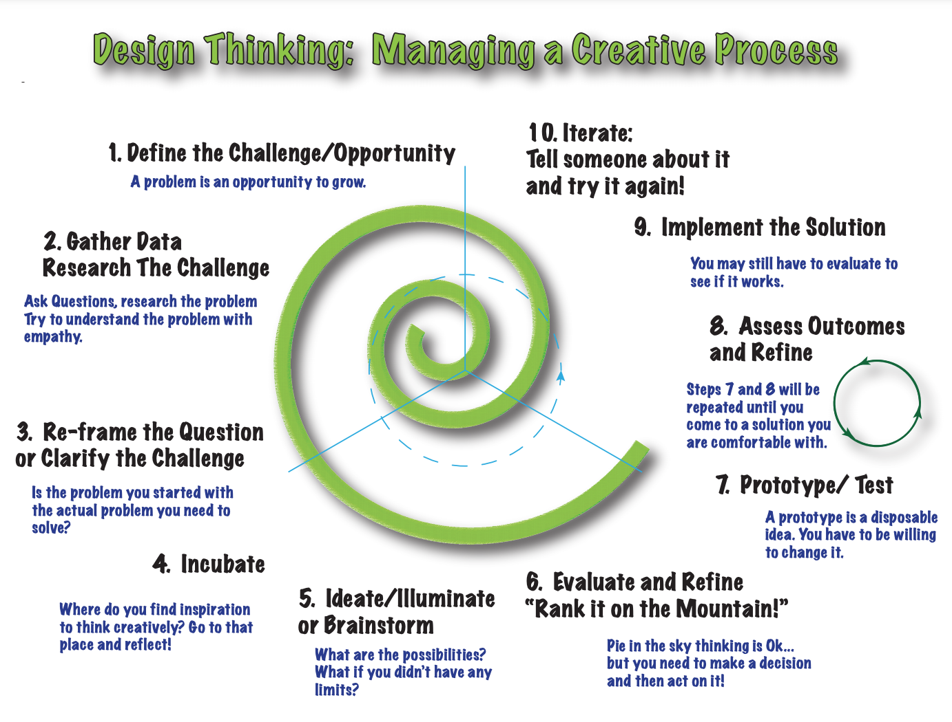

| Step of the Process | Evidence/Documentation |
| --- | --- |
| Define the Challenge | How can we invent a tool to stop an egg from breaking/cracking after being dropped at a distance of 5 meters, with the materials provided. |
| Gather Data and Research | Periouse activities/ notes that can help with calculations and or information about the acceleration of egg drops:  <https://docs.google.com/document/d/1LmDI1xrErEeRgGBS2ET5W81LTJXoKaLXac0cnlnNyQw/edit?usp=sharing> ( shop acceleration of an egg dropped from 3m )  <https://docs.google.com/document/d/1d_GlCGcCa24iPTDT9KKG_ZTZtNqsnc62XhD1Jgy5fTk/edit?usp=sharing>  ( general notes on acceleration )  Pages 32-40) all related to falling speed ex. <https://docs.google.com/presentation/d/1-qznZRdENHuh5wxIwdP5JfFP847ECd1d9BSx9Kiz_BY/edit?usp=sharing>  **Videos and other sheets:**  <https://www.youtube.com/watch?v=0KIqwT_NBh0> ( demonstrates the absorbency of an egg on foam)  **Research on other egg drops from in class and online:**    Ex from the classroom    **Others strategies and trends:**  ( The trends I noticed just from a google search on an egg drop: most the designs attempt to keep the egg away from the ground by creating distance and basically ¨acrafitial¨ straws and on stiks that are made to adsorb the impact instead) there are also attempts to adsorb the impact of the egg into another material. And the egg seems to alway be secured to something to keep it from moving.)  **Questions that need to be answered:**   1. Time of collision? 2. Speed of the egg 3. Acceleration of the egg over 5 meters 4. The force the egg has upon collision 5. **The mass of the egg** and the design 6. **The strength of the eggshell/ The density of thickness of the egg shell** 7. **The amount of force needed to put on an egg until it cracks** 8. The adormancy of an egg 9. **Point of impact** 10. **The area/ volume of the egg** 11. The length of the egg 12. **The force of gravity upon the egg** 13. Surface area of the egg 14. What part of the egg( at what height) does the egg crack upon impact) 15. Air resistance on the egg 16. What Materials are capable of distributing the weight of the egg 17. Damage/ amount cracked upon impact 18. What materials are we working with 19. What materials are most likely to break the egg 20. How sharp must a material be to break the egg 21. Are we allowed the tape or directly place something on the egg 22. Will a egg be more or less susceptible to damage if its in motion or still   Answers so far( from internet/ gathered knowledge)=  Average mass of an medium egg 49.6 g and 1.75 oz  Average density of and eggshell : 2.50 g/cm3  2.49476 to crack an egg  Point of impact is concrete ground  9.8 |
| Re-Frame the Question | Create a device/tool that is able to prevent an egg from breaking or cracking when dropped from 5 meters, using the materials provided, the knowledge of physics that I have learned and scientific reasoning( note include evidence).( if considering class challenge: light weight, fast and still capable of protecting the egg) |
| Incubate | What would happen if the egg was swinging  Weighing down the bottom to make it faster  Impact zone fourth away from the egg by using other materials  Using wind resistance in the favor  Spherical shape affect/ make the egg move faster= prevented by changing the shape or making a cover/ cloth plastic  Make thesaurus the surface area never makes contact with the ground = have other materials absorb the impact  I know eggs are staring when the weight is not directed onto one area= how can I incorporate this into the design  Main frame to secure the egg ( think the skeleton of a car) |
| Brainstorming Your Illuminated Ideations!!! | **List of materials provided**: <https://tamdistrict.instructure.com/courses/3453/pages/contest-rules-and-acceptable-materials?module_item_id=131990>  Design sketches: |
| Evaluate and Refine | First degine was built as a triangular pyramid but this design was too similar to the example so we scrapped that prototype and added sticks on the main structure, creating a 6 sided structure(pentagon) that comes to a peak at the top  **Design 1:**    First design to similar because the basic skeleton shape of the structure and the idea of the egg in the center  **Design 2:**    The differences from the first prototype design: the basic skeleton structure with the overall uneven pentagon shape and the position of the straw to only the bottom instead of all the sides. Also the placement of the cup is more towards the top of the structure and the cup is not secured with sticks instead of string. The cup has more direct contact with the skeleton instead of being extended, keeping it more secure.  Ideas implemented: aside from what mentioned above,   * we decided to remove the idea of surrounding the structure in note cards (originally to make more wind resistance) in order to make it fall faster. * Added a weave like structure of straws to make the skeleton more secure and add further support, and to add more resistance impact * Use a coving over the top of the cup so the egg is not injured if the structure flips over (paper card) * Using string as ties because it seems more secure then the glue |
| Prototype/Test | **Building process photo :**  **After the test photo:**    Weight of the prototype: 30.7 g  **Video of test:** <https://drive.google.com/drive/folders/1lblIFXMQIsf-LqNNFprNYrkLFpiRuFih?usp=sharing> (video 2)  (note: I did not get a chance to do this test in the classroom because of the time problem, so when I did do this test there is not an exact height but I am approximating about 2.5 meters. For this reason the calculations will not be accurate and this test is to merely see the effects of the impact.  **Equations**: there are no equations for this prototype because we did not gain enough information the height is unknown and the time is unknown because of the slow mo effect of the video. And it is not from the height that it will be of the true test so the data will tell us little  but…...I did it anyway:  (note: slowmo time makes it 4X slower so to find to time divided by 4 )  **Time**: dropped at 12.5 sec lands at 18 sec 81-12.5= 5.5/4= 1.375 sec  **Weight/mass**: 30.7g = mass (M = W( in kg) ÷ G) W= .0307(9.8) = 0.3011 Newtons  **G**( force of gravity)= 9.8  Instant( at the moment) velocity: V( end of fall)= g(t) v= 9.8(1.375) = 13.475 m/s  **Data from test/observation :** in the video we can see the upon impact the structure hits the bottom on the straws but the struces seemingly unmoved telling us that the impact has been mostly absorbed by the straws, then it bounces releasing the energy within the straws, and proceeds to land on its side. The side impact bends and crumples the struves and looks a little concerning. This tells us that the straws are much stronger than the sticks and provide better support of the skeleton, but they have a bigger volume causing more wind resistance. |
| Outcome Assessment and Refinements | Success for around 2.5 m  Video: <https://drive.google.com/drive/folders/1lblIFXMQIsf-LqNNFprNYrkLFpiRuFih?usp=sharing> (video 2)  **Things that need to be refined (problems):**   * the string - I noticed that when the impact hit, the string that was securing the cup were pulled down that could possible harm/ cause the egg to fall out * The overall structure: the pentagon structure was not very even causing the weight distribution to be uneven and making an unreliable result. * Cup not secure enough( hot glue not reliable)   **Solutions implemented for these problems:**   * Instead of just tying the string to the sticks I connected it to the top of the structure as well preventing it from falling/moving down and keeping it in place * I used a outline to a line the structure before gluing/tying thesticks together * I used string as well as/instead of glue to secure the intersections and the main structure of the skeleton * And to attack the cup |
| Solution Implementation | **Final product:**    Changes implemented: string, cup more secure, used a web/like cage on the top of the egg instead of just the card to have it more secure  Made the structure more narrow and compact, and the pentagon more even. The ends of the straws are more cut which causes less wind resistance. Straws higher up/ securing the structure more  able to reduce the weight by 8.7%  **After the drop:**  **Spreadsheet**:  <https://docs.google.com/spreadsheets/d/16YwlavDqFcHhLlw5c0Dz6Hzd1a8KRxZ2t4cBCvvSC_I/edit#gid=0>  **Video**:  <https://drive.google.com/file/d/10VtEYxRtJhCjQqo3rkUOOL9nE1hjygMK/view>  Finding the final time calculations: (used slow to find more exact)  Time of release 6 sec time of impact 7.15 sec difference 7.1-6= 1.1 sec  Equations(evaluation):  Velocity ( at the end) v=g(t) v=9.8(1.1) = 10.78m/s  Find the mass-= w=86g = .086kg =0.843 Newtons  KE= 1/2m(v)² KE= ½(.843N)(10.78m/s)= (.4215)(10.78)= 4.54 Joules    a= 10.78-0/1.1 = 9.8( correct it should always be the force of gravity)  Success(egg survival) : 1(yes)  Observations: Fell on side on second impact, bounced pretty high, top of cup was a little crushed against the frame. Straws moved down the fram(sill secure)  Things to improve:  the skeleton was too fragile and bended to much: next time I would try to use straws for the main structure or put all the sticks in straws  The cup was still to far down on the structure and the bottom(where the egg is) could get hit: I would make it higher up  If I was going to make it faster and lighter I would get rid of the excess straws and sticks even if they add a fail safe and try to focus on securing other elements  Try to make it even more narrow and secure the cup to the main structure to prevent using unnecessary materials |
| Final Reflection | Conclusion(thoughts on the project and thoughts on the process ): I thought that this project helped me better visualize the aspects of acceleration and how things such as weight, air resistance, gravity and height all have an effect on acceleration and falling. So instead of just knowing the formulas I got A chance to see why and how they worked in relation to a problem and each other. I do wish we had some more time to do more precise tests and work in a more calculator based manor. And were able to make more prototypes and collect more data (especially for my group specifically) since I didn't get to do a prototype in class and get a clear set of data.Despite thatI thought that project was fun and it was good to get the build something and be more hands-on which we haven't been able to do much of this year. I do wish I had done this project alone because my partner didn't really attempt to make any contributions. |

*evidence will be whatever information you discovered, researched, created in each step. It can be pictures of prototypes, videos of impacts, spreadsheets of analysis etc. Convince me!